**Paediatric Local Anaesthetic Wound / Nerve Catheter**

Wound/nerve catheters allow for local anaesthetic (LA) to be administered to the site of a surgical incision in order to improve post-operative pain. All children receiving local anaesthetic through a wound or nerve catheter must be assessed regularly to ensure safe and effective pain management, with the aim of reducing post-operative analgesic requirements and hastening return of function such as mobilisation.

In theatre a catheter is inserted into the posterior margin of the incision or in the fascial planes near the wound. A dressing is applied to hold the catheter in position. After an initial dose of local anaesthetic is given on insertion further boluses can be administered every 4-6 hours, with a maximum of 4 doses in 24 hours. Top-up bolus doses are administered by the Paediatric Pain Service (anaesthetists and pain clinical nurse specialists).

The catheter is usually left in-situ for a maximum of 72 hours, unless a longer duration is instructed by an anaesthetist.

A patent IV cannula must be in place to administer IV drugs/fluids should side effects occur and remain in-situ for 6 hours after the last local anaesthetic bolus was given.

**Prescribing / dosing information**

* Top-up bolus doses only to be administered by the Paediatric Pain Service (anaesthetists / pain CNSs)
* If the patient is obese use ideal body weight to calculate drug dosages. See acute pain guidelines.
* If multiple catheters are in-situ the total dose must be divided between all catheters

|  |  |  |  |
| --- | --- | --- | --- |
| **Local anaesthetic** | **Frequency** | **Dose** | **Comments** |
| Levobupivacaine 0.25%  ≤ 6 months | 6 hourly, can be given after 4 hours but  max. QDS | 0.2 – 0.4 mL/kg  Max. single dose: 5 mL | Levobupivacaine: max. safe dose in 4 hours: 1 mg/kg (2)  Wound catheter: start at lower volume to avoid leakage  Nerve catheter: start at higher volume  Liaise with surgeon to determine volume and risk of leakage relevant to patient and wound / nerve catheter. |
| Levobupivacaine 0.25%  > 6 months | 6 hourly, can be given after 4 hours but  max. QDS | 0.2 – 0.8 mL/kg  Max. single dose: 20 mL  If it appears that a higher volume is needed discuss with consultant anaesthetist | Levobupivacaine: max. safe dose in 4 hours: 2 mg/kg (2  Wound catheter: start at lower volume to avoid leakage  Nerve catheter: start at higher volume  Liaise with surgeon to determine volume and risk of leakage relevant to patient and wound / nerve catheter. |

* 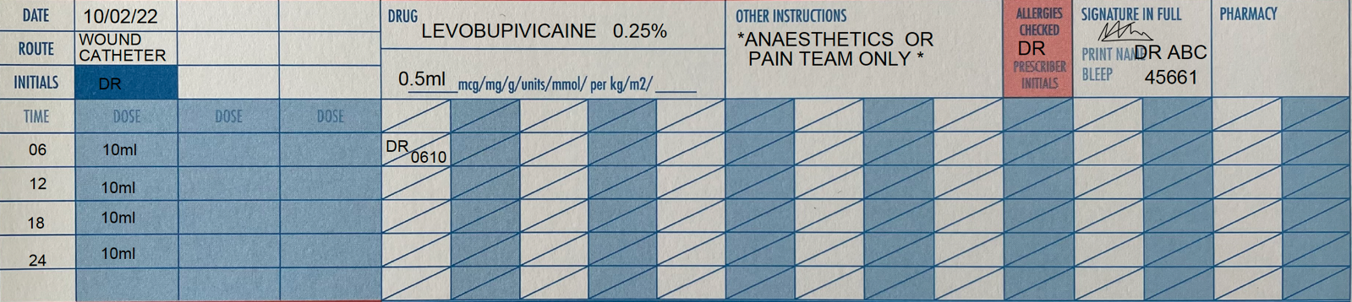The prescription should be written on the regular section of the drug chart, whenever a dose is administered it should be signed for and the time noted. See the example prescription below.

**Observations**

* Routine post-operative observations (every 15 minutes in recovery, every 30 minutes for 2 hours, hourly for 4 hours, 4 hourly for the duration of the catheter)
* Hourly pain assessments
* 4 hourly local anaesthetic catheter site assessments for signs of inflammation (4 hourly) and leakage
* After local anaesthetic top-up bolus administration: HR, RR, BP, SaO2 every 15 minutes for 1 hour
* Monitor for signs of local anaesthetic toxicity

**Signs of Local Anaesthetic Toxicity**

High local anaesthetic levels can cause systemic toxicity, this can be life threatening.

|  |  |
| --- | --- |
| **Early signs of LA toxicity** | **Late signs of LA toxicity** |
| Drowsiness / light headedness / disorientation  Tingling around the mouth / lips  Metallic taste  Numbness of tongue  Tinnitus or visual disturbances  Muscle twitching / tingling sensation | Sudden alteration in mental status / disorientation / severe agitation  Loss of consciousness  Convulsions  Cardiac arrhythmias  Cardio-respiratory arrest |

**Action**

* If early signs of LA toxicity are present contact the on-call paediatric anaesthetist (bleep 1061 or phone 45661) or pain CNS (bleep 1109) immediately.
* Deteriorating cardiovascular and/or neurological observations are late signs of LA toxicity and must be treated as a medical emergency. In case of cardiovascular collapse or respiratory arrest: **crash call 2222**

Refer to: AAGBI Safety Guideline and Management of Severe Local Anaesthetic Toxicity (Association of Anaesthetist of Great Britain and Ireland, 2010)

**For further information see trust guideline:**

Management of Paediatric Peripheral Nerve Blocks and Local Anaesthetic Infusions via Peripheral Nerve Catheters

**References:**

1. Roberts, S. (2023) *Regional Anaesthesia in Paediatric Patients: General Considerations,* NYSORA, accessed 10th February 2023, < <https://www.nysora.com/topics/sub-specialties/pediatric-anesthesia/regional-anesthesia-pediatric-patients-general-considerations/#toc_TOXICITY-OF-LOCAL-ANESTHETIC-DRUGS>>
2. Morton, NS. (2004) ‘Local and regional anaesthesia in infants’, *BJA Education,* vol. 4, no. 5, pp. 148-151