**Top tips for PCA/NCA with only one IV access in the ward setting**

* There will be patients who are on a PCA/NCA in whom IV access is very difficult. The gold standard is two IV access points however this guideline will highlight strategies that could be used if siting a second cannula is unsuccessful. This guide is only for use in the WARD setting. When anaesthetising a patient, two cannulae must be sited, including CVC or leaderflex. Consider siting a central line or leaderflex.
* There are some drugs where compatibility with other drugs is either unknown or are **incompatible**. **Drugs compatible with morphine and fentanyl** are listed in the tables at the end of this guideline. It should be assumed that any drug not listed in this table is incompatible.
* Morphine and fentanyl are compatible with most drugs. The dilution and volume of opioid in the deadspace of an existing line is highly unlikely to cause adverse events in the patient. The following diagram illustrates how to connect the lines to the cannula.

* **Oxycodone is incompatible with other drugs**. Do NOT share access for oxycodone PCA/NCAs except for maintenance fluids with no additives.
* If both accesses are lost, consider siting a subcutaneous PCA/NCA (see below). This can be used as a temporising measure whilst obtaining new access.

**Subcutaneous PCA/NCA**

* For further information, see “subcutaneous PCA/NCA” section of the PCA/NCA guideline.

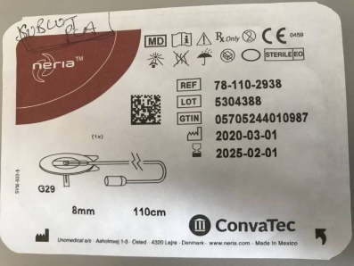

* Subcut prescriptions can be found in the pain folder. Choose special protocol F/G on the PCA/NCA pump.
* Use the infusion set available (see picture) from the anaesthetic office (in a box under the CNS desk) or from ward 6B (Daycare). Attach the PCA/NCA line to the administration set

* Alternatively, use a butterfly needle (22G) and attach the PCA/NCA line to it.

**Compatibility Tables**

|  |
| --- |
| **Drugs Compatible with**  **BOTH (morphine and fentanyl)** |
| Acetylcysteine |
| Adrenaline |
| Alfentanil |
| Amiodarone |
| Aprotonin |
| Atracurium |
| Cisatracurium |
| Clonidine |
| Dobutamine |
| Dopamine |
| Dopexamine |
| Esmolol |
| Gentamicin |
| Glucose 5% |
| Glyceryl Trinitrite |
| Insulin |
| Isosorbide Dinitrite |
| Ketamine |
| Labetolol |
| Midazolam |
| Milrinone |
| Noradrenaline |
| Paracetamol |
| Potassium Chloride |
| Remifentanil |
| Rocuronium |
| Sodium Chloride 0.9% |
| Sodium Nitroprusside |
| Total Parenteral Nutrition/Lipids |
| Vecuronium |

|  |
| --- |
| **Drugs Compatible with FENTANYL ONLY** |
| Aminophylline |
| Calcium Gluconate |
| Furosemide |
| Heparin |
| Morphine |

|  |
| --- |
| **Drugs Compatible with MORPHINE ONLY** |
| Calcium Chloride |
| Compound Sodium Lactate |
| Fentanyl |
| Glucose 4% Nacl 0.18% |
| Magnesium |
| Metronidazole |
| Salbutamol |
| Vancomycin |