Mild Pain
DRUG | FORMULATION  (available at BH) | ROUTE | DOSE  (age = corrected gestational age)  Use ideal body weight if obese (see appendix 1) |  | CONTRA-INDICATIONS | COMMENTS
Paracetamol | Suspension:  250 mg/5 mL,  120 mg/5 mL,  Tablets:  500 mg (plain and soluble)  Suppositories:  60 mg, 120 mg, 240 mg, 500 mg  Injection:  1g/100 mL | PO | > 32 weeks – 3 months: (Refer to Neonatal formulary if <32 weeks) |  | Caution in liver impairment  Do not give suppositories to oncology patients | - Consider adult dosing at 12 years + and body weight > 50 kg in the non-obese child.  - Can be combined with NSAIDs and opioids  - In A&E check if any doses given at home  - Give oral when possible as rectal route is slowly absorbed and unreliable  - Medication to be reviewed at 3 days  - Review IV therapy after 48 h
Paracetamol |  | PO | Maintenance dose:  1 10-15 mg/kg 6-8hly | Max dose:  60 mg/kg/day
Paracetamol |  | PO | >3 month:  Max dose: 60 mg/kg/day
Paracetamol |  | PO | Loading dose: 20 mg/kg  Maintenance dose:  15 mg/kg 4-6hly | Max single dose: 1 g  Max 4 g/day  Postoperative: 75 mg/kg/day
Paracetamol |  | PR | > 32 weeks – 3 months: (Refer to Neonatal formulary if <32 weeks)  Loading dose: 30 mg/kg Max dose: 60 mg/kg/day  Maintenance dose: Max post-op dose in > 1 month:  15-20 mg/kg 6-8hly 75 mg/kg/day
Paracetamol |  | PR | >3 months:  Max dose: 60 mg/kg/day  Loading dose: 20 mg/kg Max single dose: 1 g  Maintenance dose: Max 4 g/day  15 mg/kg 4-6hly Postoperative: 75 mg/kg/day
Paracetamol |  | IV | 32-36 weeks:  Maintenance dose: 7.5 mg/kg 8hly Max dose: 25 mg/kg/day
Paracetamol |  | IV | Term neonate and child < 10kg:  Maintenance dose: 10 mg/kg 8hly Max dose: 30 mg/kg/day
Paracetamol |  | IV | Child > 10kg:  Max dose: 60 mg/kg/day  Maintenance dose: 15 mg/kg 6hly Max single dose: 1 g  Max 4 g/day

Moderate Pain
DRUG |  | FORMULATION  (available at BH) | DOSE  (age = corrected gestational age)  Use ideal body weight if obese (see appendix 1) | CONTRA-INDICATIONS | COMMENTS
Ibuprofen  (Not for oncology patients) | Either/ or | Suspension:  100 mg/5 mL  Tablets: 200 mg,  400 mg | >1 month – 3 months:  Maintenance dose: 5 mg/kg 6hly  Max dose: 20 mg/kg/day | Oncology patients  Bleeding disorder  Peptic ulcer  Do not give suppositories to haematology/oncology patients  Caution: renal, hepatic and cardiac impairment, asthma (regular inhaler use) and hypovolaemia | - Ibuprofen and diclofenac must ideally be given with/after food or milk  - Review 24 hourly if NBM/gastrointestinal disorder  - Consider gastro protection  - Can be combined with paracetamol and opioids  - Do not use if the child is currently receiving chemotherapy or bone marrow transplant  - In individual cases IV diclofenac can be given. Contraindicated with low dose molecular weight heparin. Dose: 1 mg/kg - 12 hly;  Max. 150 mg/day.
Ibuprofen  (Not for oncology patients) | Either/ or | Suspension:  100 mg/5 mL  Tablets: 200 mg,  400 mg | > 3 months:  Maintenance dose: 7.5 mg/kg 6hly  Max dose: 30 mg/kg/day  - up to a maximum of: 1.2 g/day  If >12 years and >40 kg: 400 mg – 8hly  For rheumatological conditions contact rheumatologist for dosing
Diclofenac  (Not for oncology patients) | Either/ or | Tablets: 25 mg,  50 mg enteric coated, 50 mg dispersible  Suppositories:  12.5 mg, 25 mg,  50 mg | Under 6 months and less than 8kg:  Do not prescribe
Diclofenac  (Not for oncology patients) | Either/ or |  | >6 months and >8kg:  Maintenance dose: 1 mg/kg 8hly  Max single dose: 50 mg  Max dose: 150 mg/day  Total daily dose for rectal route may be given in 2 divided doses
Codeine phosphate |  | Elixir: 25 mg/5 mL  Tablets:  15 mg, 30 mg, 60 mg  IM injections:  30 mg/mL,  60 mg/mL | > 12 years:  Maintenance dose: 1 mg/kg 4-6 hly  Max single dose: 60 mg  Max dose: 6 mg/kg/day  - up to a maximum of 240 mg/day | Under 12 years  Obstructive sleep apnoea  Post tonsillectomy and/or adenoidectomy  Known CYP2D6 ultra rapid metaboliser  Do not give with other opioids  Never give intravenously  No IM injections for haematology/oncology patients | - Consider rapid escalation to morphine for oncology patients  - Beware of constipation (morphine preferable in gastro patients)  - MHRA alert June 2013 restricted use in children over 12 years
DRUG |  | FORMULATION  (available at BH) | DOSE  (age = corrected gestational age)  Use ideal body weight if obese (see appendix 1) | CONTRA-INDICATIONS | COMMENTS
Dihydrocodeine |  | Tablets: 30 mg can be halved and quartered with tablet cutter. Then crush or swallow.  Liquid available but not recommended due to high alcohol content (9.1%). Preparations with no alcohol are unlicensed and difficult to obtain. | 1 - 4 years:  Maintenance dose: 0.5 mg/kg 6hly  > 4 years:  Maintenance dose: 0.5 mg/kg 6hly  If no response dose can be increased to 1 mg/kg 6hly  Max single dose: 60 mg up to a maximum of 240 mg/day | Acute respiratory depression  Obstructive airways disease  Pancreatitis  Known CYP2D6 ultra rapid metaboliser  Dihydrocodeine should not be given during acute exacerbation of asthma.  Severe hepatic dysfunction  Head injury or intracranial pressure  Do not give with other opioids | - Dihydrocodeine may cause histamine release  - Caution post tonsillectomy and/or adenoidectomy. Not contra-indicated but it has the same metabolic pathway as codeine phosphate
Tramadol |  | Capsule: 50 mg  Tablet: 50 mg (soluble),  Injection:  100 mg/2 mL | > 12 years:  Oral maintenance dose: 50 - 100 mg 4-6hly  Max dose: 400 mg/day  For post-operative pain:  IV/IM: 100 mg initially then 50 mg every 10 – 20 minutes if necessary during first hour to total max. 250 mg (including initial dose) in first hour,  then 50- 100 mg every 4 – 6 hours  Max dose: 600 mg/day | Acute intoxication with central nervous system depressants (alcohol, hypnotics, centrally acting analgesics, opioids, psychotropic drugs)  Severe hepatic or renal impairment.  (creatinine clearance less than 10ml/min)  Severe respiratory impairment.  Uncontrolled epilepsy | - Use with caution with other opioids  - Since June 2014 CD class 3: Prescribe as per CD regulations in words and figures
Morphine  (for moderate pain) |  | Short acting  Liquid: 10 mg/5 mL,  100 mg/5 mL  Tablet: 10 mg | All ages:  Maintenance dose: 0.1 – 0.2 mg/kg 3hly,  - for neonates 4hly  Max single dose: 10 mg | Caution in respiratory depression, sedation, renal- and liver impairment | - Can be combined with NSAIDs and paracetamol  - Usually prescribed “as required” (prn)

Severe Pain – See equivalent doses of opioid analgesics in appendix 2
DRUG | FORMULATION  (available at BH) | DOSE  (age = corrected gestational age)  Use ideal body weight if obese (see appendix 1) | CONTRA-INDICATIONS | COMMENTS
Morphine  (for severe pain)  1st line analgesia of choice in severe pain | Short acting  Liquid:  10 mg/5 mL,  100 mg/5 mL  Tablets: 10, 20mg | Neonates:  Maintenance dose: 0.1 – 0.2 mg/kg 4hly  All other ages:  Maintenance dose: 0.2 – 0.4 mg/kg 3hly  Max single dose: 20 mg (max in sickle cell 25 mg)  Sickle cell pain:  See ED: “sickle cell protocol in children” and “sickle cell protocol in adolescents” | Caution in respiratory depression and sedation, renal and liver impairment | - Monitor pain relief, sedation level, oxygen saturation, respiratory pattern and rate  - If respiratory depression develops:  - Stop the infusion/administration (if applicable)  - Administer oxygen,  - Stimulate patient,  - Commence BLS,  - Administer naloxone  (4-10 mcg/kg IV), SC/IM if no IV access available but onset slower. Consider naloxone infusion (see BNFc for dose).  - Contact Pain Service if at RLH or relevant medical team if at Newham or Whipps Cross  - Can be combined with NSAIDs and paracetamol  - If pain persists call Pain Service (for contact details see “Appendix 3”)  - Short acting opioids usually prescribed “as required” (prn)  - Long acting opioids usually prescribed on “regular site” on drug chart  - Consider starting laxatives with regular opioids
 | Long acting / modified release  Sachets:  20 mg, 30 mg, 60 mg  Tablets  5 mg, 10 mg, 30 mg, 60 mg | All ages:  1 mg/kg every 12 hours  - Long acting (e.g. MST®) should only be prescribed after having established total daily opioid requirement (unless sickle cell crisis)  Sickle cell pain:  See ED “sickle cell protocol in children” and “sickle cell protocol in adolescents”
 | Intravenous bolus | See IV monograph
 | PCA/NCA | RLH: contact Pain Service (for contact details see “Appendix 3”)  Whipps Cross: contact anaesthetic team or medical team  See “PCA/NCA for the paediatric patient in acute pain – clinical practice policy”
Fentanyl | PCA/NCA | RLH: contact Pain Service (for contact details see “Appendix 3”)  Whipps Cross: contact Anaesthetic team or Medical team  See “PCA/NCA for the paediatric patient in acute pain – clinical practice policy”
Oxycodone | Short acting  Liquid:  5 mg/5 mL, 10 mg/mL  Capsules: 5 mg,  10 mg, 20 mg | ORAL:  1 month – 12 years: initially 200 micrograms/kg (up to 5 mg) every 4 to 6 hours: dose may be increased  12 – 18 years: initially 5 mg every 4 to 6 hours: dose may be increased
Oxycodone | Long acting /  modified release / prolonged release  Tablets: 5 mg, 10 mg, 20 mg, 40 mg, 80 mg | ORAL:  8 - 12 years: initially 5 mg every 12 hours: dose may be increased  >12 years: initially 10 mg every 12 hours: dose may be increased  - Long acting should only be prescribed after having established total daily opioid requirement

Procedural Pain
DRUG | FORMULATION  (available at BH) | DOSE | CONTRA-INDICATIONS | COMMENTS
Entonox® | Piped Entonox® available at ward at RLH, otherwise order cylinder via oxygen porter | As required | See “Guidelines For Administration Of Entonox® To Children” | For procedural pain only
Intranasal Diamorphine | Made up in ED from injection - see guidance | see guidance |  | Paediatric Emergency Department Only
Ketamine |  | see guidance |  | Paediatric Emergency Department Only

Neuropathic Pain
DRUG | FORMULATION  (available at BH) | DOSE  (age = corrected gestational age)  Use ideal body weight if obese (see appendix 1) | CONTRA-INDICATIONS | COMMENTS
Gabapentin | Capsules:  100 mg, 300 mg, 400 mg  Tablets and liquid available on special order. Not stocked on site. | 2 - 18 years:  Day 1 5 mg/kg (max 300 mg) od  Day 2 5 mg/kg bd  Day 3 5 mg/kg tds  Maintenance dose: 5 mg/kg TDS after dose build-up  Can be increase to 10 mg/kg for a minimum of 6 weeks for a range of 2 – 6 months  Titration up to tds may take several weeks if unable to tolerate side effects.  Max dose: 1.8 g/day  Peri operative scoliosis surgery:  Admission day: 10 mg/kg (max. 300 mg) od  Op. day: 10 mg/kg (max. 300 mg) bd  Post-op. days: 10 mg/kg (max. 300 mg) tds continue until discharge day then stop. | Caution: avoid abrupt withdrawal  Caution in use with diabetes, BMs must be carefully monitored.  Caution in history of psychotic illness | - Capsules can be opened and bitter taste masked with blackcurrant or cola drinks  - Wean off gradually over several weeks (except for peri operative scoliosis surgery)
Amitriptyline | Tablets:  10 mg, 25 mg,  50 mg  Liquid:  50 mg/5 mL | 2 - 12 years:  Initially 200 – 500 micrograms/kg (max: 10 mg) nocte,  Increase if necessary to max: 1 mg/kg bd on advice by Pain Service.  Higher doses given (up to 25 mg daily) on specialist advice  12 - 18 years:  Initially 10 - 25 mg nocte,  Increase gradually if necessary to usual dose 75 mg at night; higher doses on specialist advice | Arrhythmias  Severe liver disease  Acute porphyria  Caution: avoid abrupt withdrawal | - Causes sedation, dry mouth, blurred vision – side-effects dose dependent  - Reduce dose in renal impairment  - Risk of serotonin syndrome if given with tramadol  - Wean off gradually over several weeks

Appendix 1- Table from BNF with estimated age/weight in Paediatrics

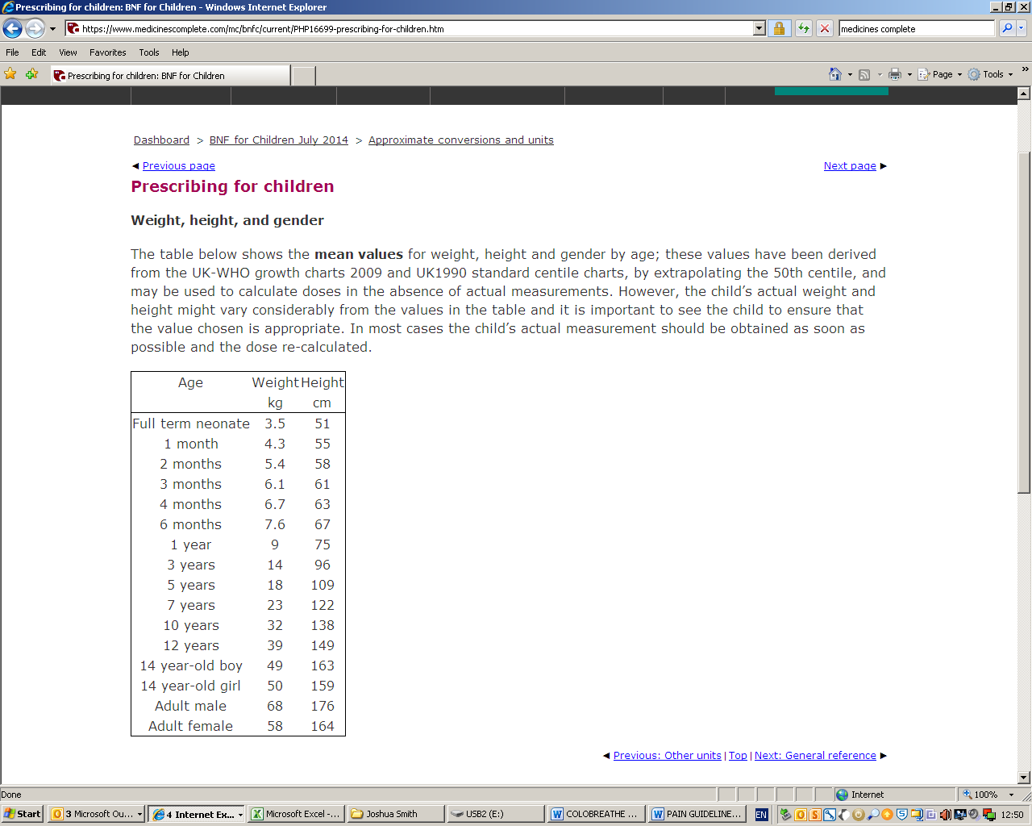

Appendix 2 - Table from BNF with equivalent doses of opioid analgesics

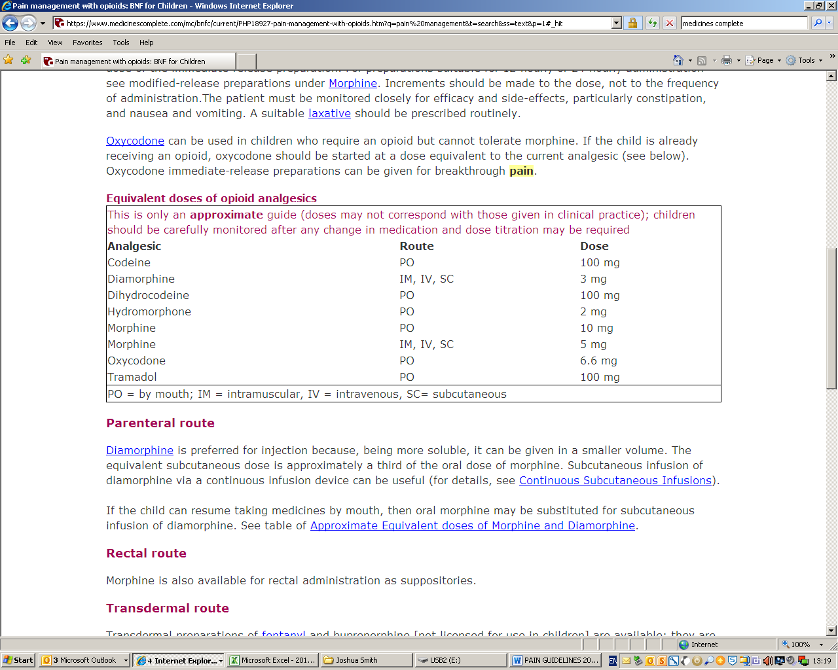
Appendix 3 – Paediatric Pain Service contact details:

The Paediatric Pain Service is based at RLH
Pain Clinical Nurse Specialists: bleep 1109 (during office hours), phone: 0203 594 1298 (answer machine out of office hours)
Anaesthetist on-call: bleep 1061, dect phone: 45661)

Reviewed by: Acute Paediatric Pain Team, February 2018 Next Review Date: February 2020

Original authors and authors December 2017:
Alice Lo, Operational Service Lead Pharmacist, W&C
Veronica Chorro-Mari, Highly Specialist Pharmacist, Women’s Services
Jo Challands, Consultant Paediatric Anaesthetist
Ulrike Sigg, Clinical Nurse Specialist, Acute Paediatric Pain Service
Ambia Ali, Clinical Nurse Specialist, Acute Paediatric Pain Service

References:
BMA, RPSGB, RCPCH, NPPG. Online BNFc, accessed February 2018
Guy’s and St Thomas’, King’s College and University Lewisham Hospitals. Paediatric Formulary, 9th edition.
Mason, D.G. (2017) Fifteen-minute consultation: Pain relief for children made simple-a pragmatic approach to prescribing oral analgesia in the postcodeine era.
Archive of Disease in Childhood - Education and Practice. 0, pp.1-5, doi:10.1136/archdischild-2016-311613 [accessed: 14 June 2017].
Martindale online, last acessed 14/12/2017
MHRA/CHM June 2013 Codeine for analgesia: restricted use in children due to reports of morphine toxicity

