|  |  |
| --- | --- |
| **Standard Operating Procedure:**  **Name of Department:**  **Date Effective From:**  **Written By:**  **Contributions:** | * Tracheostomy patient transfer safety * Paediatric Respiratory * Lucy Quirk * Respiratory consultants, ENT consultants and Paediatric Long Term Ventilation Clinical Nurse Specialists. |

|  |  |
| --- | --- |
| Purpose | * To ensure safety of tracheostomy patients both non-ventilated and long term ventilated patients who require transfer across the hospital. For example ward to ward, ward to theatres, etc. * To ensure that the correct equipment is with the patient and in correct working order. * Outline clear safety procedures around the tracheostomy patient. * For tracheostomy patients to have 1:1 care by a professional that is tracheostomy competent and that this is scheduled in advance for staffing safety. |

|  |  |
| --- | --- |
| Scope | * All professionals around the team working within the children’s hospital to take responsibility in ensuring equipment is with patient at all times and in working order prior to transfer. * To use the appropriate checklist continuously when caring for a tracheostomy patient. * To make sure that when a patient is scheduled to attend that tracheostomy competent staff are available to care for them 1:1 and can be available for the transfers. * For example at time of scheduling for a tracheostomy patient non-ventilated or long term validated this is clearly documented on admission request. This then needs to be documented on the admission list and making sure the ward 6B or 7E and Respiratory CNS’ are made aware in advance. |

|  |  |
| --- | --- |
| Definition | * To ensure that the airway is safe and protected. * The blue tracheostomy box, patient ventilator (with external battery for transfer) and suction should remain with the child at all times, this includes whilst in theatres during procedure. * Making sure as staff we can safely care for a patient when transferring them, and ensure that in an emergency we are prepared to manage the situation. * For parents to be explained to regarding leaving the equipment with the child (patient ventilator, suction and emergency blue tracheostomy box) * To communicate with ward staff, CNS’ or parent if there are any concerns when using the equipment. |

|  |  |
| --- | --- |
| Key Working Relationships | * Respiratory consultants * Clinical nurse specialists * Nursing staff * Paediatric critical care team * Families * ENT consultants * Speech and Language * Respiratory physiotherapists * Anaesthetists * Theatre teams * Sleep Physiologists and teams |

|  |  |
| --- | --- |
| Responsibilities | * Provide safe and efficient care of a tracheostomy patient and long term ventilated tracheostomy patient on transfer. * To support each other as multi-professionals and develop our skills and knowledge around tracheostomy patients. * To obtain Tracheostomy Bed Head sign from Q drive and place it above the child with correct information filled out. (please see in Appendix A and B. * The use of effective communication between professionals and families. * Use of the appropriate checklist for each patient and documentation of the used checklist on CRS. |

|  |  |
| --- | --- |
| Procedure / Process | * Make sure the environment (ward, theatres or day care) where the tracheostomy child will be is a safe working environment. * Make sure on scheduling TCI or prior to arrival of tracheostomy patient staffing is checked and filled to facilitate 1:1 care and transfer. * Prior to transfer use either long term ventilated tracheostomy patient checklist or non-ventilated tracheostomy patient checklist, ensuring that you are safe to move the patient to their ward, procedure or transfer. * Ensuring all equipment is with the patient; * Patient ventilator (Long term ventilated patient) * Emergency blue tracheostomy box * Suctioning equipment * Oxygen (if needed) * Ambu-bag * Saturation and Heart Rate monitor * Humidifier (non-long term ventilated patient) * Tracheostomy Bed head sign (please see appendix A and B) * Document use of appropriate checklist on CRS. * Make sure on transfer that one parent or carer and one nurse (tracheostomy competent) is with the patient at all times. * Make sure transferring nurse (tracheostomy competent) is allocated to be available to collect child when recovery call. * Maintain patient safety at all times throughout the transfer. * Communicate and handover (using appropriate handover tool) with staff on arrival of patient, what equipment the child has with them and that the checklist was used. * All equipment should remain inside the theatre during procedure and be transferred with the patient to recovery. (equipment should never leave the child) * When the child is in recovery the ward nurse should be called to help facilitate transitioning the patient from anaesthetic ventilation to long term home ventilation equipment. The anaesthetist should remain with the patient until the tracheostomy competent ward nurse and parent or carer arrives and the patient is stable. * For non-ventilated tracheostomy patients – wake as normal and if oxygen is needed deliver through Swedish nose or trachphone. Then the child can be transferred safety back to the ward or day care. |

|  |  |
| --- | --- |
| Infectious Control Procedures | * Continue following trust infection control policy. * For example PPE, AGP or cleaning of equipment. |

|  |  |
| --- | --- |
| Documentation | * Upload checklist onto CRS and document any changes in regards to the patient. * Document where equipment is and who it has been handed over to. |

|  |  |
| --- | --- |
| Stock | * If any stock issues or equipment queries then communicate with CNS team, 7E NIC or PCCU team. * If out of hours to contact PCCU or 7E respiratory. |

|  |  |
| --- | --- |
| Flow Chart/Checklist | * Please see appendix A, B, C, D and E |
| Staff competencies | * The senior members of all teams are trained and competent in care and transfer of a tracheostomy patient. * Participating in the tracheostomy Statutory and Mandatory training day/requirements are essential. * The staff transferring tracheostomy patients are responsible in reading and using SOPs and knowing where they are located in the shared drive. * The staff member transferring the patient and using the checklist is aware of the importance of the completion of electronic records. * It is the responsibility of all colleagues within the Children’s hospital to adhere to this SOP to ensure good practice, standard of care and safety is available to all patients with a tracheostomy. |

|  |  |
| --- | --- |
| Governance | * Safeguarding must be considered for patients. * Incorrect / inadequate use of SOP that may be detrimental to the patient’s health must be reported as a Datix incident. * All pressure sores that are identified, a Datix incident report must be completed. * Any equipment errors or broken equipment identified that means a delay in care or procedure must be reported as a datix. * Ensure duty of candour for any incidents affecting patients. * CNS respiratory team responsible for holding tracheostomy study day. |

|  |  |
| --- | --- |
| Known risks | * Staffing capacity may change * Equipment malfunctions |

|  |  |
| --- | --- |
| Appendices | Appendix A: Checklist document  Appendix B: Checklist document  Appendix C: Flow chart  Appendix D: Flow Chart  Appendix E: Equipment description pictures |
| Descriptions/ Abbreviations | * Tracheostomy: A permanent or temporary opening into the trachea that is held in place by a tracheostomy tube to allow a child to breathe easily. * Swedish nose or trachphone: Tracheostomy humidifiers * ENT: ear, nose and throat * CNS: Clinical Nurse Specialists * NIC: nurse in charge * TCI: to come in * HME: Heat and moisture exchagers |

|  |  |
| --- | --- |
| SOP Written by: | Lucy Quirk |
| Authorised by: |  |
| Review Date: | Review in 3 years |

Appendix A:

**Long Term Ventilated Tracheostomy Patient Transfer Checklist**

**Blue Emergency Tracheostomy box contents.**

* Same size tracheostomy (patient specific)
* Shiley half size down
* Suction catheter (same size used by patient)
* Mouth to tracheostomy valve
* Tracheostomy tube ties
* Velcro tracheostomy tube ties (only to be used in an emergency)
* Tracheostomy dressing
* Gauze
* Saline
* HME or Swedish nose (if used by patient)
* Round ended scissors
* Water based lubricant
* 10ml Syringe (if cuffed trache tube)

|  |  |
| --- | --- |
| **Checklist:** | Y/N |
| **Tracheostomy Size ( )**  **Suction length ( )** |  |
| Patient ventilator (correct circuit) |  |
| Patient Blue Emergency Tracheostomy box |  |
| Suction (Correct size suction catheters) |  |
| Saturation and Heart rate monitor |  |
| Oxygen (if needed) |  |
| Ambu-bag |  |
| Tracheostomy bedhead sign and filled in |  |

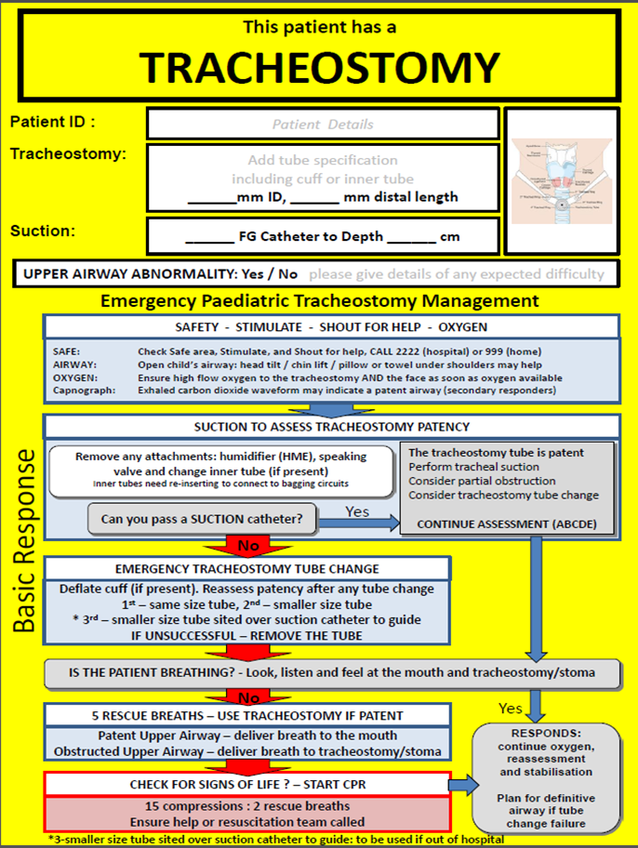

Appendix B:

**Non-Ventilated Tracheostomy Patient Transfer Checklist**

**Blue Emergency Tracheostomy box contents.**

* Same size tracheostomy (patient specific)
* Shiley half size down
* Suction catheter (same size used by patient)
* Mouth to tracheostomy valve
* Tracheostomy tube ties
* Velcro tracheostomy tube ties (only to be used in an emergency)
* Tracheostomy dressing
* Gauze
* Saline
* HME or Swedish nose (if used by patient)
* Round ended scissors
* Water based lubricant
* 10ml Syringe (if cuffed trache tube)

|  |  |
| --- | --- |
| **Checklist:** | Y/N |
| **Tracheostomy Size ( )**  **Suction length ( )** |  |
| Patient Blue Emergency Tracheostomy box |  |
| Suction (Correct size suction catheters)  (Patient dependent) |  |
| Saturation and Heart rate monitor |  |
| Oxygen (if needed) |  |
| Ambu-bag |  |
| Tracheostomy bedhead sign and filled in |  |



Appendix C:

Long term ventilated Tracheostomy patient on ventilator in day care, and non-ventilated tracheostomy patient in day care.





Patient does not have correct equipment.





Use correct checklist to prepare patient to move to theatre.

Call Resp CNS’, Sleep team or Resp ward 7E.



Theatre ready.

Problem corrected.



Have all the correct equipment.



Patient stable.



Patient ready to move and has all working equipment with them.



Patient ready to move to the ward or theatres.

Appendix D:

Long term ventilated Tracheostomy patient on ventilator in theatres, and non-ventilated tracheostomy patient in theatres.





Patient does not have correct equipment.





Use checklist to prepare patient to move to from theatre to ward bed.

Call Resp CNS’, Sleep team or Resp ward 7E.





Have all the correct equipment.

Problem corrected.





Ward/Bed ready.

Patient ready to move.

Patient stable on own long term ventilator.

Appendix E:

Tracheostomy bed head sign:

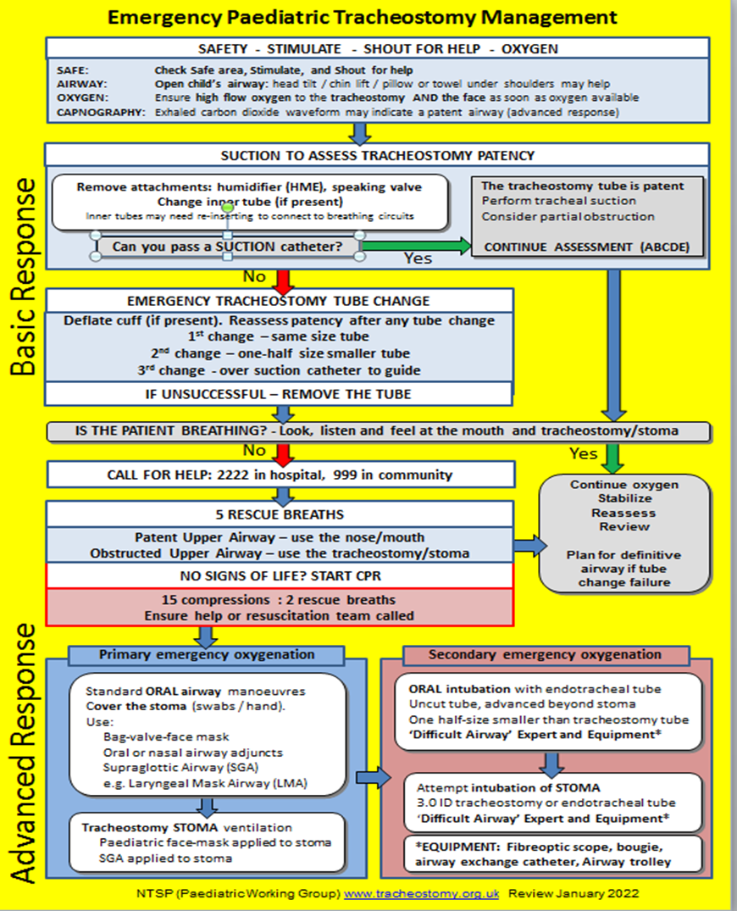



Tracheostomy humidifiers:

