
CHILDREN’S DIVISION
COVID-19 FAQ’s 02.04.20

WHAT’S NEW: 2
GUIDANCE 4
TESTING PATIENTS 4
➢ Which patients DO need testing? 4
➢ How do I test a patient? 5
➢ Do I need to take any special precautions sending the sample to the lab? 5
➢ Should I send repeat swabs on children with suspected COVID-19? 5
➢ When is the best time to send the swab for COVID-19? 5
ADMITTING AND TRANSFERRING PATIENTS 5
➢ How will we transfer patients who are possibly infected between clinical areas? 5
➢ Which lift will be used to transfer children with possible COVID from A&E? 6
➢ Is there any advice for patients in Bengali or other languages? 6
➢ How do I organise transport home for a patient with confirmed COVID-19? 6
➢ What changes have been made to the age-limit policy across the Children’s hospital? 7
INFECTION CONTROL GUIDANCE, INCLUDING PERSONAL PROTECTIVE EQUIPMENT 7
➢ What PPE should I wear when seeing patients? 7
➢ How can I wash re-usable visors/goggles? 8
➢ Where can my ward get PPE Stock? 8
➢ Do I need “fit-testing”? 9
➢ What do I do with drug charts for patients with suspected/confirmed COVID-19? 9
➢ What happens if another patient is exposed to a patient with confirmed COVID-19 (that was not suspected on admission?) 9
➢ What happens if I am exposed to a patient who has COVID-19? 9
➢ How do we dispose of plates and cutlery used by confirmed or suspicious COVID cases? 9
CLINICAL CONSIDERATIONS TREATING CHILDREN WITH SUSPECTED COVID-19 9
➢ Children with safeguarding Concerns 9
➢ Ibuprofen in patients with suspected/confirmed COVID-19 9
➢ Dexamethasone in viral wheeze/asthma 10
➢ Should I examine the throat of a child? 10
GUIDANCE FOR STAFF ON SICKNESS AND SELF-ISOLATION 10
➢ What do I do if I’m unwell or a household member is unwell? 10
➢ How can I (or a household member who is unwell) access testing? 10
ELECTIVE SURGERY AND OUTPATIENT CLINICS 11
➢ Will elective procedures/surgery be cancelled? 11
➢ What about outpatient clinics? 11
STAFF WHO ARE PREGNANT OR WITH CHRONIC HEALTH CONDITIONS 11
➢ Staff who are pregnant 11
➢ Staff with Chronic Health Conditions 11
➢ Contacting Occupational Health 12
FOOD, PARKING AND ACCOMODATION 12
➢ Where can I get food from whilst I’m on shift? 12
➢ Where can I park my car, if I drive to work? 12
➢ How can I access emergency accommodation? 12
GETTING IN AND OUT OF THE HOSPITAL 12
➢ How can I get in and out of the hospital? 12
➢ Should I wear scrubs to work? 13
➢ How many people can there be in a lift? 13
ANNUAL AND STUDY LEAVE 13
OTHER INFORMATION 13
➢ Can nursing students look after patients with possible/confirmed COVID -19? 13
➢ Are we continuing to have medical students on the wards? 13
➢ Where will I get updates? 13

WHAT’S NEW:
- Are staff with symptoms being tested for COVID-19?
Staff testing is now available for up to 150 staff a day – staff in critical care and emergency departments will be prioritised. There is also capacity to test household members of staff members who are symptomatic (where staff would otherwise have to self-isolate for 14 days.) If you are unwell, or have a household member is unwell, please contact Occupational Health between the hours of 08:00-10.00 to request a test, and inform them you are unwell/self-isolating.
Call 07827307479 or e-mail Bartshealth.occhealth.covid19testing@nhs.net.
Please also e-mail Gavin James – gavin.james@nhs.net (Divisional manager,) if you think you being back at work is particularly critical, so he can escalate the request.
Occupational health will review requests based on key criteria. Staff/household members will be asked to attend screening at the Royal London Hospital or the O₂ drive through facility.

- Can staff be tested at other testing faculties?
There are several other faculties offering testing for NHS staff, including IKEA at Wembley and Chessington World of Adventures, which are validated for testing. All requests for testing should come through occupational health.

- If a staff member tests positive, when can they return to work?
Staff can return to work at 7 days (post onset of symptoms,) if they are afebrile and symptoms are improved. It is expected they may still have a cough.

- Should I send repeat swabs on children with suspected COVID-19?
Due to rising numbers of tests being performed, the virology team have advised that repeat throat/nose swabs for COVID-19 should not be sent. The only exception is children who deteriorate and require intubation, who should have a deep airway sample sent. Children with high clinical suspicion of COVID-19 should continue to be managed as suspected COVID-19 (kept in cubicle, PPE used,) if initial testing is negative.

- Is the virology laboratory still testing other respiratory viruses?
The virology laboratory is no longer testing for influenza and other respiratory viruses. If you have a child with a negative swab for SARS-CoV-2, who is still febrile with respiratory symptoms, please e-mail virology team to request for influenza and other respiratory viruses to be tested. E-mail: bartshealth.virologyconsultants@nhs.net

- When is the best time to send the swab for COVID-19?
The sensitivity (pick-up rate) of the test is highest 2-5 days after onset of symptoms. If you admit a patient with symptoms for 24 hours or less, you may want to wait 24 hours to send the swab for SARS-CoV-2. If you do this, the patient should still be nursed in a cubicle with PPE.

- Should children with Cystic Fibrosis have more than one swab sent for COVID-19?
If children are having chest physiotherapy and producing lower respiratory tract samples, these can be tested in addition to a combined throat/nose (upper respiratory tract sample.) SARS-CoV2 can be present in the lower respiratory tract, despite being undetectable in the upper respiratory tract.
- What changes are there to patient flow across the children’s hospital?
Ward 7C is temporarily closed.
7D (PASSU) will take all acute admissions with suspected COVID-19, from ED.
7Ea will remain a general medical/surgical ward. All oncology patients will be admitted directly to 7Ea side, into a cubicle, if one is available. If a cubicle is not available they should come through ED as per the normal pathway.
7Eb will be predominantly restricted to respiratory patients. Each admission to be discussed on a case-by-case basis with the on-call respiratory or general paediatric consultant.
7Fa ward will remain a general/gastroenterology ward.
Children’s day care is moving to 7Fb side.
Children’s Theatres has moved to level 3, North Tower (Paediatric Emergency Theatre is in ACAD theatre 2.) The morning emergency meeting is still at 8.30am in ACAD reception.
No parents are allowed to go down with children to theatres – please communicate this sensitively to families. If nursing staff are going down to theatres with children with suspected/confirmed COVID, they need to wear PPE.
- How do I get hold of the pain team?
In–hours, please direct queries to bleep 1109 – Uli and Ambia will provide a 7 day a week service. Out-of-hours please contact the anaesthetic registrar on bleep 1061.
- What changes are there to patient transport?
When booking patient transport, please specify whether patient is suspected or confirmed COVID or not. This will affect which transport crew comes to collect the patient. Failure to do this may result in delays if the wrong transport crew comes. Wherever possible, families should organise their own transport home from hospital.
- What is the current hospital visiting policy?
The hospital is currently closed to visitors. No visitors are allowed for adult patients. Only one adult/family member is allowed per child at a time. If patients are on non-invasive ventilation, the parent should stay with the child for the duration of their time on non-invasive ventilation, and not swap with other family members.
- When can I move children out of cubicles?
Children with a negative COVID-19 swab should have a clinical risk assessment done. If they have ongoing symptoms concerning for COVID-19, they should remain in a cubicle and infection control precautions continued. If there is no ongoing suspicion of COVID-19, they can be moved out of a cubicle to a bay.
- What’s happening with the Nightingale Hospital?
Bart’s Health has taken on formal legal responsibility for the operation and governance of the NHS Nightingale Hospital, working closely with NHS London and the project team that is setting it up. If you are e-mailed or asked to work there, this needs to go through your line manager, and the divisional management team.
- Should I wear PPE if I’m called to a resus call across the children’s wards?
Further guidance will follow on this, but it is recommended you wear PPE for all resus calls across the 7th floor.

GUIDANCE

TESTING PATIENTS

Which patients DO need testing?
Patients only need to be tested if they are being admitted to hospital, and fulfil the criteria below. Children who attend ED, or are in the community with suspected COVID-19, do not need to be tested unless they require admission. They should follow guidance on self-isolating at home (https://www.nhs.uk/conditions/coronavirus-covid-19/self-isolation-advice/) and contact NHS 111, if their symptoms worsen or they are not better by 7 days.

- Children with fever above 37.8ºC and no clear focus
- Children with pneumonia
- Children with new persistent cough
- Children with flu-like symptoms (hoarseness, nasal discharge or congestion, shortness of breath, sore throat, wheezing, sneezing)
- Children with a chronic respiratory condition, being admitted
- All patients being admitted to 7Eb side

Children who have a swab sent for suspected COVID-19 should be admitted to a cubicle, with infection control precautions.

How do I test a patient?
Send a single viral swab per patient. Swab the back of the throat first and then the nasal cavity. On CRS, Select ‘coronavirus (2019-nCoV)’ and then nose throat swab.
There is now no need to e-mail the virology team specifically to let them know samples are coming. Do not use NPA’s to test for COVID-19, as it is a potential aerosol generating procedure. Further details are available on the Coronavirus guidelines, under trust guidance.

Do I need to take any special precautions sending the sample to the lab?
Standard precautions similar to handling any body fluid samples should undertaken. All samples should be double bagged prior to sending to the lab.

Should I send repeat swabs on children with suspected COVID-19?
Due to rising numbers of tests being performed, the virology team have advised that repeat throat/nose swabs for COVID-19 should not be sent. The only exception is children who deteriorate and require intubation, who should have a deep airway sample sent. Children with high clinical suspicion of COVID-19 should continue to be managed as suspected COVID-19 (kept in cubicle, PPE used,) if initial testing is negative.

When is the best time to send the swab for COVID-19?
The sensitivity (pick-up rate) of the test is highest 2-5 days after onset of symptoms. If you admit a patient with symptoms for 24 hours or less, you may want to wait 24 hours to send the swab for SARS-CoV-2. If you do this, the patient should still be nursed in a cubicle with PPE. Repeat swabs should not be sent.

ADMITTING AND TRANSFERRING PATIENTS

How will we transfer patients who are possibly infected between clinical areas?
It is important that children are transferred from ED to the ward areas and between wards areas safely to protect staff as well as our patients. The Divisional team have created a flow chart showing where patients will be isolated and a standard operating procedure detailing how to transfer them safely.

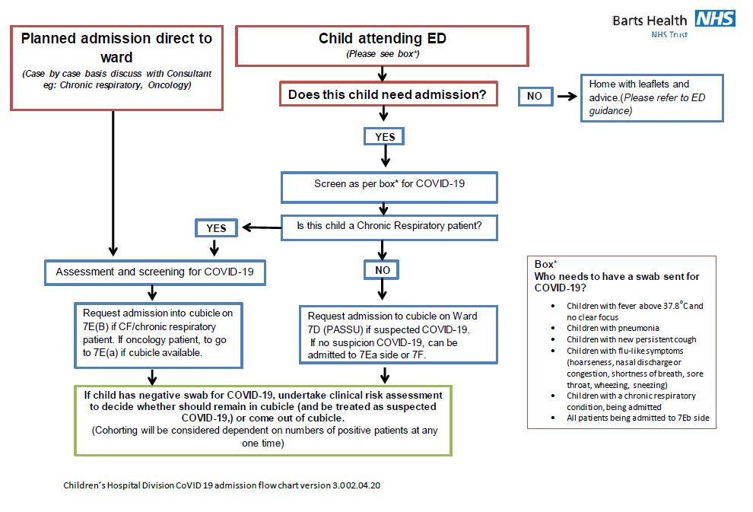

If in doubt all admissions should be discussed with the 1107 bleep holder and if necessary the attending general paediatric consultant on 45733.

Which lift will be used to transfer children with possible COVID from A&E?
Children will be transferred thought Lift 4, hence we would advise NOT to use Lift 4 to prevent contact.

Is there any advice for patients in Bengali or other languages?
Doctors of the World have developed Coronavirus (Covid 19) advice for patients in 21 languages, available at: https://drive.google.com/open?id=193qQN9l04Dvf0N9L5zeWTiXK_DRbrAxg
Please try to open this in Google Chrome.

The guidance is based on the government’s updated advice and health information.

How do I organise transport home for a patient with confirmed COVID-19?
Please contact Becky Bilsom in patient transport, if transport is required. When booking patient transport, please specify whether patient is suspected or confirmed COVID or not. This will affect which transport crew comes to collect the patient. Failure to do this may result in delays if the wrong transport crew comes. Wherever possible, families should organise their own transport home from hospital.

What changes have been made to the age-limit policy across the Children’s hospital?
As of the 27th March, paediatric ED and the 7th floor paediatric wards will be seeing/admitting young people up to their 18th birthday, to help ease pressure on adult services. There are two automatic exceptions to this role: 1. Patients who require care from the O+G team will continue to follow the current O+G pathways. 2. Patients over the age of 16 years who have been trauma called – they will continue to follow the adult trauma call pathways.

INFECTION CONTROL GUIDANCE, INCLUDING PERSONAL PROTECTIVE EQUIPMENT

What PPE should I wear when seeing patients?
There is likely to be a change to infection control guidance in the next 48 hours, with a move to using basic PPE (gloves, a plastic apron and a fluid-resistant surgical mask,) for all patient contact. We will disseminate this guidance when it becomes available.

Advice for staff:
- If you are caring for a confirmed or suspected patient, use gloves, apron and fluid-resistant surgical mask. The use of disposable visors should be risk assessed for each individual patient. FFP3 masks and visors should be used for patients with confirmed COVID-19 on high-risk settings (HDU/ICU.)
- If you are providing care to a confirmed or suspected case undergoing aerosol generating procedure, use full PPE (gown, gloves, FFP3 mask and visor).

What is an aerosol generating procedure?
- Intubation, extubating and related procedures
- Tracheotomy / tracheostomy procedures
- Manual ventilation
- Open suctioning
- Bronchoscopy
- Non-invasive ventilation (NIV)
- High-frequency oscillating ventilation (HFOV)
- High-flow Nasal Oxygen (HFNO)

Theatre caps are not required as part of PPE in ward areas.
Further guidance is available on the Coronavirus weshare pages including videos and donning/doffing instructions: https://weshare.bartshealth.nhs.uk/index.cfm?page=coronavirus-treatment

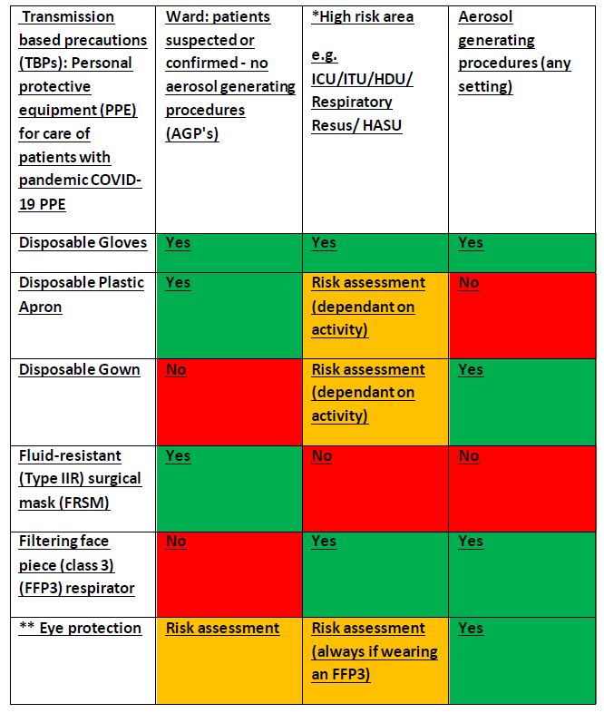

How can I wash re-usable visors/goggles?
Infection control have advised that re-usable visors and goggles can be washed with green clinell wipes.

Where can my ward get PPE Stock?
If you require further supplies of personal protective equipment (PPE,) procurement is open from 8am – 8pm weekdays, and 8 – 4pm weekends. If you require emergency PPE stock out with these times, please contact site surgery and ask for access – please only take the equipment you require, and not extra ‘just in case.’ Please note all items taken and ensure the area is secured once finished.
Please use the following e-mail address for queries: barts.procurement@nhs.net
Phone number, material management service (at RLH): 020 3594 6530/6531/1021

Do I need “fit-testing”?
The trust is no longer doing ‘fit-testing’ for staff, and instead is advocating ‘fit-checking.’ It is important all staff do ‘fit-checking’ each time they are using an FFP3 mask.
Guidance on fit testing is available on the WeShare Coronavirus pages.

What do I do with drug charts for patients with suspected/confirmed COVID-19?
Drug charts should stay outside the patient room, to try and prevent spread of infection.

What happens if another patient is exposed to a patient with confirmed COVID-19 (that was not suspected on admission?)
Patients who have been exposed to a patient with confirmed COVID-19 do not require testing or isolation, if asymptomatic. If they develop symptoms at a later stage, they should be tested for COVID-19, and isolated in a cubicle, until the swab results are back.

What happens if I am exposed to a patient who has COVID-19?
You do not need to take any specific precautions if you are exposed to a patient with COVID-19; if you are asymptomatic you can remain at work. If you develop symptoms, you should self-isolate and inform your line manager and occupational health, for consideration of testing. Guidance on self-isolation is available here: https://www.gov.uk/government/publications/covid-19-stay-at-home-guidance

How do we dispose of plates and cutlery used by confirmed or suspicious COVID cases?
The infection control team have confirmed that these should be treated in the same way as with any other patient that has an infectious condition; no special measures are needed.

CLINICAL CONSIDERATIONS TREATING CHILDREN WITH SUSPECTED COVID-19

Children with safeguarding Concerns
Please inform the children’s safeguarding team straight away if you see a child in ED with a safeguarding concern, that may require admission – the safeguarding team will support discussion with children’s social care, to try and prevent admission wherever possible.

Ibuprofen in patients with suspected/confirmed COVID-19
There is no conclusive evidence that ibuprofen worsens outcomes in COVID-19, but there is limited literature on this. There is some evidence from SARS that Ibuprofen may increase complications, but this is not conclusive overall. The current CMO guidance is that patients with suspected/confirmed COVID-19 use Paracetamol in preference to Ibuprofen. Those currently on NSAID’s for another reason (eg. Arthritis) do not need to stop them.

Dexamethasone in viral wheeze/asthma
The paediatric respiratory team advise that steroids (Dexamethasone) should be given if indicated to children with viral wheeze/asthma, even if they meet criteria for COVID-19 testing. There is no evidence to recommend reducing paediatric asthma medication during the current pandemic; Patients should continue their usual preventative treatment.

Should I examine the throat of a child?
During this COVID-19 outbreak, we recommend that you only examine the oropharynx (throat) of children if absolutely necessary. If the throat needs to be examined, personal protective equipment (surgical face mask, plastic apron and gloves,) should be worn irrespective of whether the child has suspected COVID-19 or not. If a child is being tested for COVID-19, staff should routinely wear PPE to collect the combined nose/throat sample.

GUIDANCE FOR STAFF ON SICKNESS AND SELF-ISOLATION

What do I do if I’m unwell or a household member is unwell?
It is advised that if you develop a new persistent cough or fever, you need to self-isolate for 7 days (unless you have been tested, and have had a negative test.) Please contact your line manager and occupational health.
If some-one from your household develops a new persistent cough or fever, you need to self-isolate for 14 days. The 14 day period starts from when the first person became unwell. Further guidance is available here: https://www.gov.uk/government/publications/covid-19-stay-at-home-guidance/stay-at-home-guidance-for-households-with-possible-coronavirus-covid-19-infection
There is an explanatory diagram available here: https://assets.publishing.service.gov.uk/government/uploads/system/uploads/attachment_data/file/873359/Stay_at_home_guidance_diagram.pdf

How can I (or a household member who is unwell) access testing?
Staff testing is now available for up to 150 staff a day – staff in critical care and emergency departments will be prioritised. There is also capacity to test household members of staff members who are symptomatic (where staff would otherwise have to self-isolate for 14 days.) If you are unwell, or have a household member is unwell, please contact Occupational Health between the hours of 08:00-10.00 to request a test, and inform them you are unwell/self-isolating.
Call 07827307479 or e-mail Bartshealth.occhealth.covid19testing@nhs.net.
Please also e-mail Gavin James – gavin.james@nhs.net (Divisional manager,) if you think you being back at work is particularly critical, so he can escalate the request.
Occupational health will review requests based on key criteria. Staff/household members will be asked to attend screening at the Royal London Hospital or the O₂ drive through facility.

ELECTIVE SURGERY AND OUTPATIENT CLINICS

Will elective procedures/surgery be cancelled?
Elective surgery has all been cancelled. Any service can cancel activity on a case by case basis depending on the pressures on that service with beds/staffing etc. or on the risk to any individual vulnerable patient. All such cancellations must be notified to the Division as they have to be reported externally by the Trust.

What about outpatient clinics?
The Trust has advised consultants to review the clinics and offer the patients phone consultation wherever possible. Managers can help with phoning staff if this is necessary.
Please ensure any such virtual reviews are accurately recoded on CRS, and outcome forms completed. Patients who DNA should be clinically vetted, and if appropriate given a further appointment, and not just discharged back to GP.
FP10’s are available from the nursing staff in outpatients, to send prescriptions to families if needed, and from Dr Naik on the 8th floor.

STAFF WHO ARE PREGNANT OR WITH CHRONIC HEALTH CONDITIONS

Staff who are pregnant
The RCOG has published new guidelines for staff who are pregnant: https://www.rcog.org.uk/coronavirus-pregnancy
The trust guideline is incorporated below.
If you are pregnant, please speak to your line manager and occupational health to discuss modifications to your work. If staff who require to work from home are unable to be deployed within the division, please send details to vanya.arbuah@nhs.net as there are other tasks they can support with.

Staff with Chronic Health Conditions
It is important that staff with chronic health conditions have a discussion with their line manager, so a risk assessment can be done. (This is available on the WeShare Coronavirus pages.) Actions will depend on the impact the condition has on normal daily activities.
For staff with conditions such as asthma, diabetes, sickle cell and who are immunosuppressed, it is advised they do not work in high-risk areas such as ITU, ED or caring for patients with suspected COVID-19.
Staff with more severe symptoms may need to consider working remotely or being deployed to a non-patient-facing area. Managers should please pass on details of staff who are pregnant or with a chronic health condition to occupational health: bartshealth.occhealth.coronavirus@nhs.net

Contacting Occupational Health
Occupational Health are now operating a 24 hour a day service. Contact details for the employee Wellbeing Service (Occupational Health) are: 0203 5946547/02073777855 or out of hours (07753319182/07810630273.)
They have a dedicated e-mail address: bartshealth.occhealth.coronavirusadvice@nhs.net

FOOD, PARKING AND ACCOMODATION

Where can I get food from whilst I’m on shift?
From this week, all staff will be entitled to free sandwiches, hot breakfasts, lunches and dinners at the canteen. You will be asked to present your ID badge at the tills. Staff can also get free tea, filtered coffee and a canned drink. Grab and go bags are also available for staff. The canteen is currently extremely busy, so we would recommend not going at peak times.

Where can I park my car, if I drive to work?
Parking fines will not be issued until 1st July 2020. From 1 April, staff with a parking permit will not be charged. If you pay via RingGo, you are advised to stop the payments. If you pay for parking out of your salary, this will be suspended for a 3 month period. Parking will be available on a first come first served basis. Register your vehicle for free on-site parking by emailing the team. NCP is also offering free car parking spaces to NHS staff. To pre-book visit their website. You can also locate a residential parking space using the JustPark app and the YouParkingSpace app.

How can I access emergency accommodation?
During this tough time, you can book a hotel room at no expense. This is recommended if a member of your family is self-isolating, if your journey to the hospital is particularly long or if you have been affected by some of the transport link closures. If you would like to book a hotel room, there is a form on the WeShare Coronavirus page https://weshare.bartshealth.nhs.uk/wellbeingcoronavirus.
Please ask your operations manager to email it to the authorisation manager. Any requests received after 9pm will not be addressed until the following morning. Further details are on the Weshare pages.

GETTING IN AND OUT OF THE HOSPITAL

How can I get in and out of the hospital?
You will need to show your ID badge to get into the front entrance of the hospital.
You can no longer enter the hospital through Stepney Way, but can get in through Luckes entrance at the back, with your ID badge.
Please remove your ID badge before leaving the building, as there have been some concerns raised that staff have been approached for their ID badge in the surrounding streets around the hospital.

Should I wear scrubs to work?
Scrubs are only allowed in the areas when they would normally be worn (PCCU and ED and neonates,) or by staff working an entire shift in a COVID-19 ward. They should not be used in other areas. Staff wearing scrubs will not be allowed to enter the hospital from outside.
Please do not take them home or stockpile them ‘just in case’. All staff must change into personal clothes for travel to and from work.

How many people can there be in a lift?
Trust guidance is that there should not be any more people than 4 in a lift at any one time.

ANNUAL AND STUDY LEAVE

It is likely that this pandemic will go on for several months. The division will support and honour annual leave commitments as these are essential for staff well-being. At present the division has no plans to cancel annual leave. As most external bodies are cancelling CPD courses, it is likely that most study leave will be withdrawn for this reason.

OTHER INFORMATION

Can nursing students look after patients with possible/confirmed COVID -19?
No, It was agreed at the Trust level that nursing students should not look after these children, however they can look after COVID negative children once results available.

Are we continuing to have medical students on the wards?
QMUL has confirmed that there will not be any medical or physician associate students in the clinical areas for the next few months.

Where will I get updates?
WeShare is available remotely and on phones (at weshare.bartshealth.nhs.uk) and updated every day with the latest information and guidance to help you do your job. The page includes travel advice; how to reduce the risk of infection; what to do should a patient presents with suspected coronavirus; and posters for your ward that you can download and print. You can access this page from the red banner or coronavirus icon on the WeShare homepage.

Sites are holding daily briefings to discuss operational and strategic issues. All staff are welcome to attend. Updates need to be incorporated into the SAFE handovers for nursing and medical staff.

