ANAESTHETIC TEAM GUIDE TO THE COVID-19 ED CUBICLES
With on-going concerns about the Delta variant, the threat of a third wave. It has been decided that high risk or suspected Covid- 19 paediatric patients be managed in a temporary ‘Resus’ Cubicles.
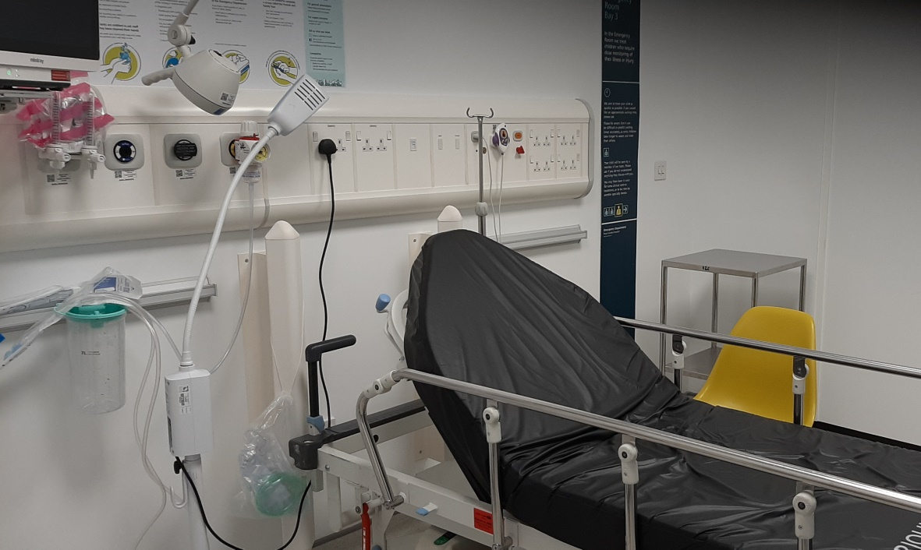

Guide to using these cubicles
- Turn the trolley 90 degrees as per the schematic below (will be done by ED nurses at pre-alert)

- Communication will be achieved by a two way intercom. If the intercom is broken then there are two way baby monitors.

- Drugs will be handed to you in a tray by ED. We have agreed that only anaesthetists will draw up the drugs. There will be a drug fridge installed in the near future.

- When intubating, only have the anaesthetic team inside the room. Ask everyone else to vacate the area.

- There is a paediatric airway trolley in this area, please see the schematic below.

- As a back-up for patients up to 2 years of age there is a grab bag on the 6th floor on the difficult airway trolley. Please feel free to use as per your preference.
O2/Air supply
Monitor

Defib
Airway trolley

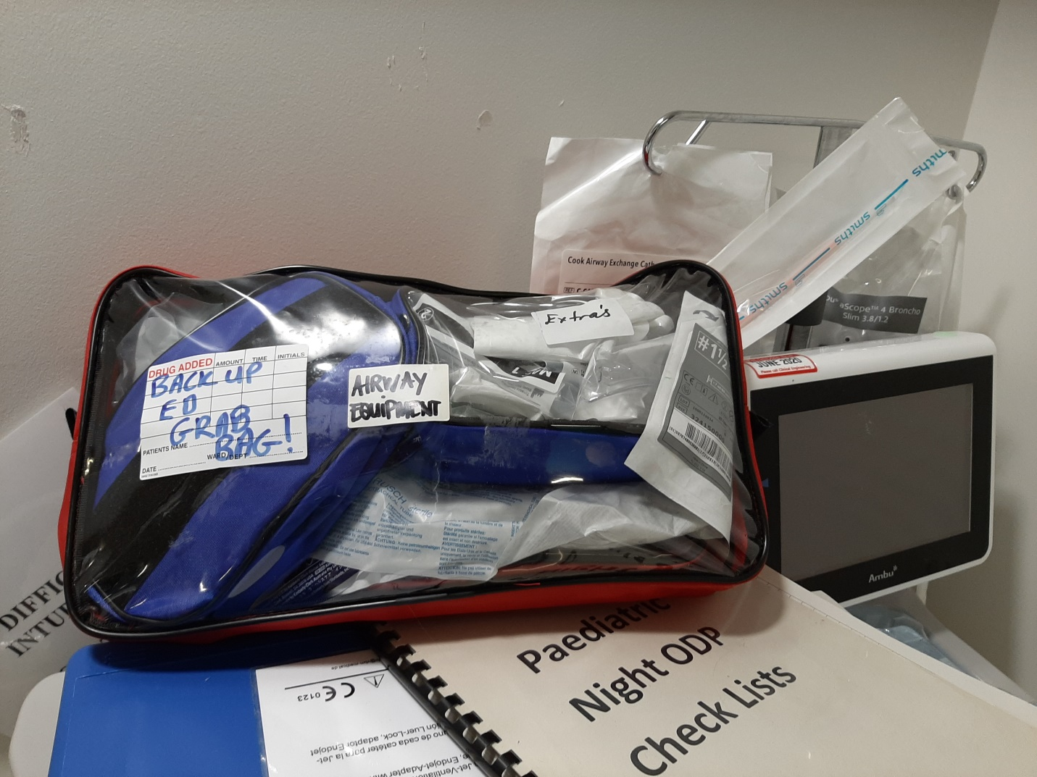
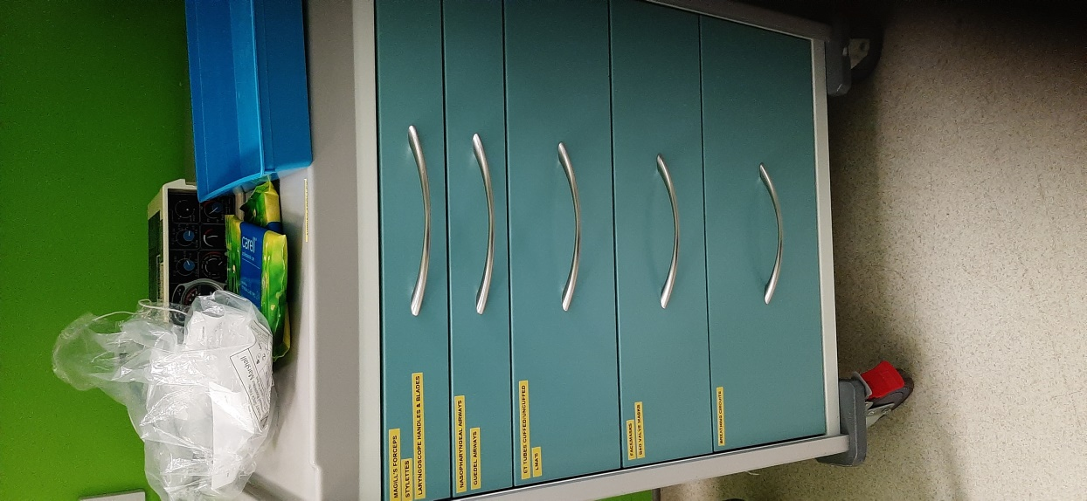
Back up grab bag for patients <2 years
Lives on 6th floor difficult airway trolley
Airway Trolley
All sizes available- Checked by ED Nurses at start of shift

